**IR Matlab Analysis Quick Instructions:**

1. Turn on IR camera (in Proto-MPEX area)
2. Launch ResearchIR (64-bit) – remote into IR-PC if needed
   1. Connect to A655sc camera
   2. Check for camera focus after few plasma shots (ask Ted if need help focusing)
3. Launch IR1.vi (pink icon on desktop)
   1. 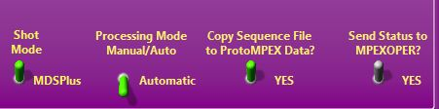Ensure **Shot Mode**, **Processing Mode**, and **Copy Sequence File to ProtoMPEX Data** are all switched to green and **Send Status to MPEXOPER** is switched to ‘yes’.
4. Launch MATLAB
   1. Ensure MDSplus program is downloaded on PC and on Matlab path*
   2. Ensure Dynamic or Static Java Path includes (type ‘javaclasspath’ into command line):

C:\Program Files\MATLAB\R2017a\java\jarext\mdsobjects.jar

C:\Program Files\MATLAB\R2017a\java\jar\mdsobjects.jar

* + 1. If not included, enter into command line:

javaaddpath('C:\Program Files\MATLAB\R2017a\java\jar\mdsobjects.jar');

javaaddpath('C:\Program Files\MATLAB\R2017a\java\jarext\mdsobjects.jar');

* 1. Open IRshot_AutoAnalysis_editedMay25.m
     1. Run this script
     2. **Q1:** “What power sources were applied? helicon only=0; ech+hel=1; ich+hel=2; all=3” (variable: powersource)
        1. **Default response: 0**
        2. If want to skip extra ECH/ICH analysis, just enter 0
        3. If ECH added: enter 1
        4. If ICH added: enter 2
        5. If ICH + ECH: enter 3
     3. **Q2**: Did additional power source(s) have full pulse? no=0; yes=1;
        1. **Default response: 0**
        2. If no additional power source – enter 0
        3. If ECH/ICH pulse may have been short – enter 0
        4. If full ECH/ICH: enter 1
     4. **Image 1:** Click center of thermocouple – see circle and arrow.
        1. Click center of that circular area
        2. This centers the image

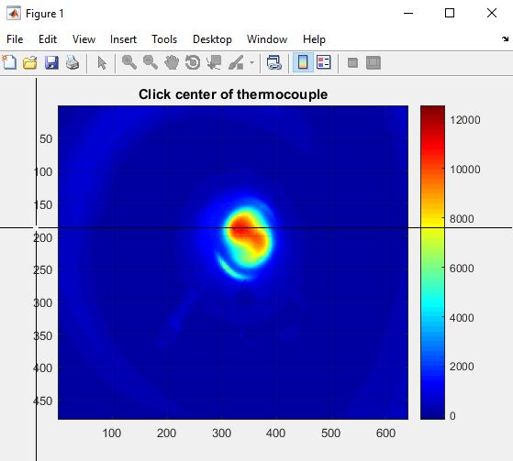

* + 1. **Image 2:** Click on approximate edge hot spot position
       1. Will be on outer edge of the plasma profile – usually in upper left, but can be upper right or lower left: here it’s the lower left (white arrow)
    2. **Image 2:** Click on approximate center hot spot position (black arrow)
    3. **Image 2:** Click approximate diameter width (red x’s)

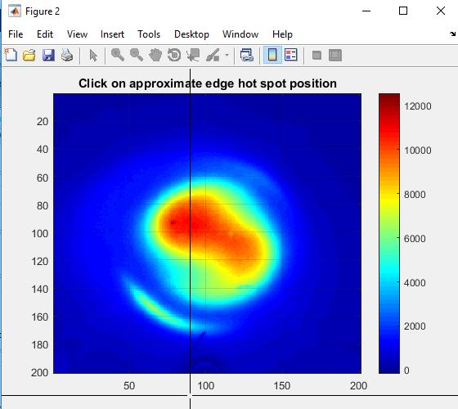

* + 1. Code will run
       1. 7 more figures will be created:
          1. Untitled temporal plot
          2. Delta T vs. Camera pixels of hottest frame
          3. Energy Flux vs. Camera pixels of hottest frame
          4. Plot Delta T between Frames (Temp vs. Frames)
          5. Plot Power Density between Frames (Power Density vs. Frames)
          6. Plot Power Density between Frames (Power Density vs. Time)
          7. Plot Power between Frames (Power vs. Time)
       2. Output of code in command window will include:
          1. Plasmaframe = frame where helicon-gen plasma first appears on the plate (will be TG)
          2. Finalframenumber = frame where the delta T is maximized
          3. Max delta T on plasma profile edge : where clicked for “approximate edge hot spot position”
          4. Max delta T on plasma profile center: where clicked for “approximate center hot spot position”
          5. Max delta T on plasma profile for small average (E1): represented by ellipse whose diameter was delineated when clicked “Click approximate diameter width”
          6. Max delta T on plasma profile for large average (E2): automatically set, delineated by large ellipse fitting within square

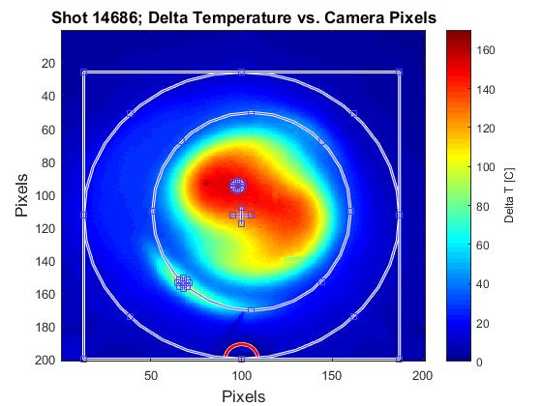

**Center Hot spot/ Helicon**

**Edge Hot spot/ ”TG”**

**E1**

**E2**

**Average**

* + - 1. If ECH or ICH are added (if variable powersource doesn’t equal 0)
         1. Additional figure generated: Delta T vs. Camera pixels subtracting frame associated with start of ECH/ICH pulse from end of ECH/ICH pulse
         2. Output code in command window will also include

Max delta T on edge from figure

Max delta T in center from figure

Max delta T small average (E1) from figure

Max delta T large average (E2) from figure

Start and end frame of the ECH/ICH pulse

* + 1. Code will save a .mat file with important variables to provide some reanalysis capabilities of the shot (will probably go to the Documents Matlab folder)
  1. **Troubleshooting**
     1. 'error: gap between two possible max delta T frames is large - manual analysis suggested'
        1. Check difference between hel_frame and framenumber – select more appropriate value (usually the lower framenumber) – can check temporal plot for guidance – should be selecting the frame where the change in temperature is maximized (max of hel_templist or meanlist)
        2. Set frame value to variable: ‘finalframenumber’ and run code from line 77.
     2. If running **heliconsourcetimes.m** or **powersourcetimes.m** throws an error
        1. Probably MDSplus connection issue – Doublecheck the variables loaded correctly.